2009 INTERNATIONAL CLIMBERS’ MEET

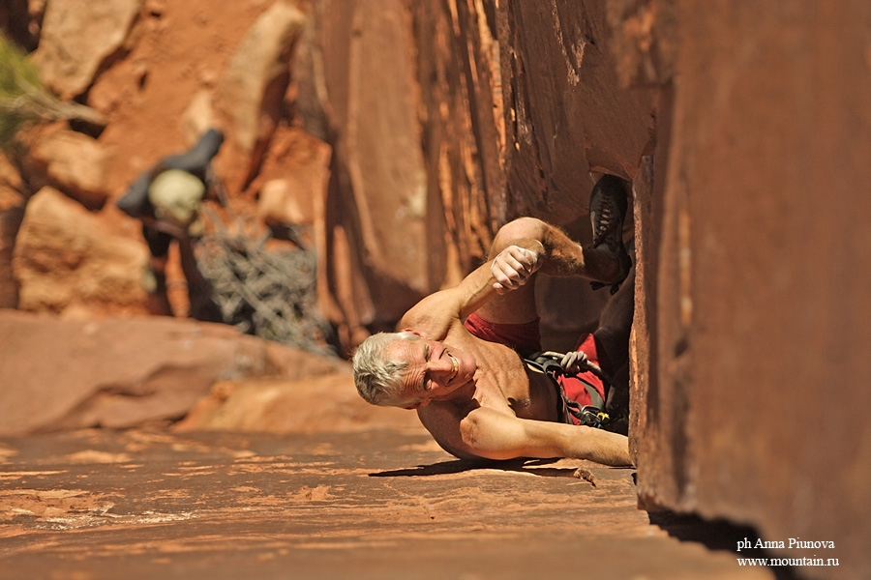

Event Schedule:

Thursday, October 1—Climbers arrive at Salt Lake City Airport.

Friday, October 2—Travel to from Salt Lake City to Indian Creek – transportation provided by AAC

Saturday, October 3 through Wednesday, October 7—Five days of crack climbing, campfires, guest speakers and slideshows at Indian Creek.

Thursday, October 8—Travel back to Salt Lake City for showers

Friday, October 9- Kick-off party for the AAC’s annual Craggin’ Classic. BBQ, beer, and mingling with celebrity American climbers.

Saturday, October 10—TBA

Sunday, October 11- TBA

Monday, October 12— Travel Home

Registration fee: $175 Visiting climbers are responsible for air travel expenses to and from Salt Lake City International Airport and their meals while not at Indian Creek.

Other expenses are covered by AAC.
Gear list for visiting climbers:
Tent, sleeping bag and pad, mess kit (i.e., bowl, plate, fork, knife, spoon, water bottles, and coffee mug). Harness, climbing shoes, chalk bag, belay device, and helmet.

For Information Contact:
Dana Richardson
Outreach Manager
drichardson@americanalpineclub.org
+1 303 384 0110 ext. 10

During the meet's weeklong run, climbers from climbing clubs and mountaineering federations throughout the world will come together to share in the unique experience of Indian Creek crack climbing. American Alpine
Club host climbers will give the visiting climbers the grand tour of the Creek, from the tasty tips cracks to the gnarly offwidths—there will be challenges for everyone, plus tons of food and more than one wild party. This is one event you won't want to miss!

